

THE HERITAGE

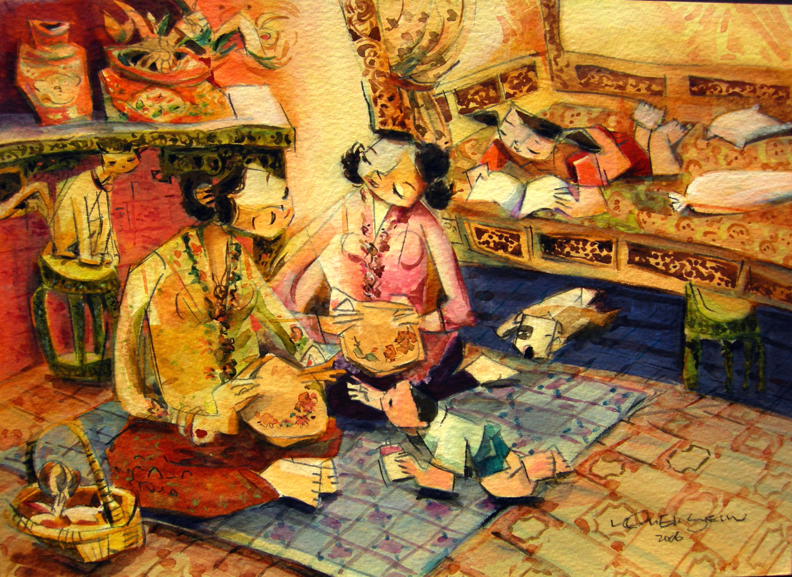
Embroidery Session
Responsibility of household management for young girls are being coached and practised at home. The quality of her sewing, beadwork and embroidery reflected her good upbringing and patience.

